Project Design Phase-II
Data Flow Diagram & User Stories
Date | 10 July 2026
Team ID | [Your Team ID]
Project Name | House Rent — Broker-Mediated Real Estate Platform
Maximum Marks | 4 Marks
Data Flow Diagrams:
A Data Flow Diagram (DFD) shows how data enters and leaves the system, what transforms it, and where it's stored. Level 0 gives the system-wide context; Level 1 breaks the system down into its core processes and data stores.
Level 0 — Context Diagram:
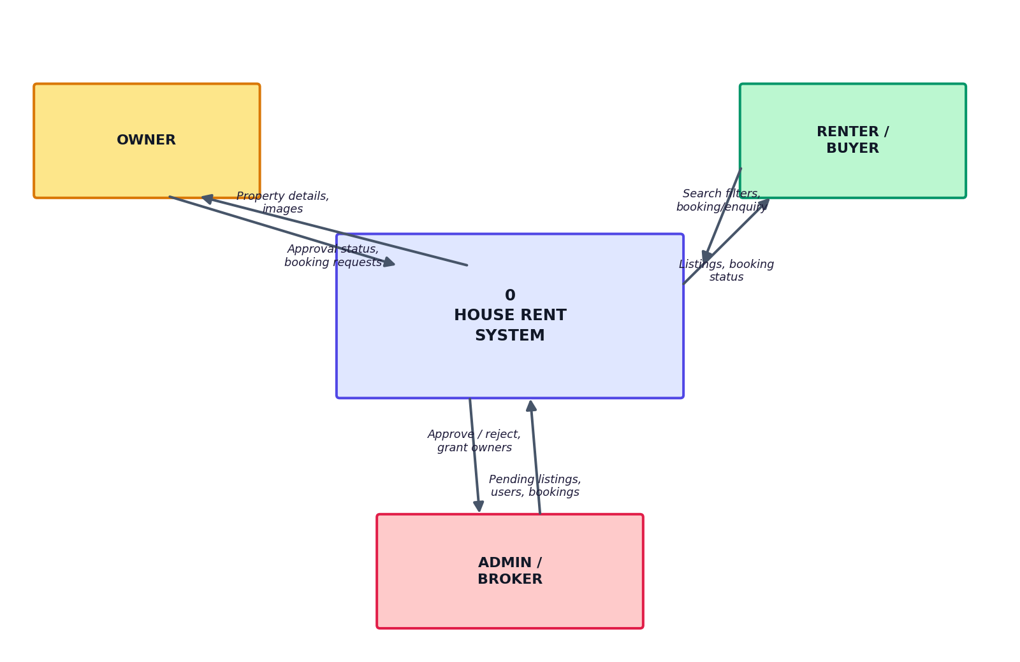
Figure 1: House Rent — DFD Level 0 (Context Diagram)
Level 1:
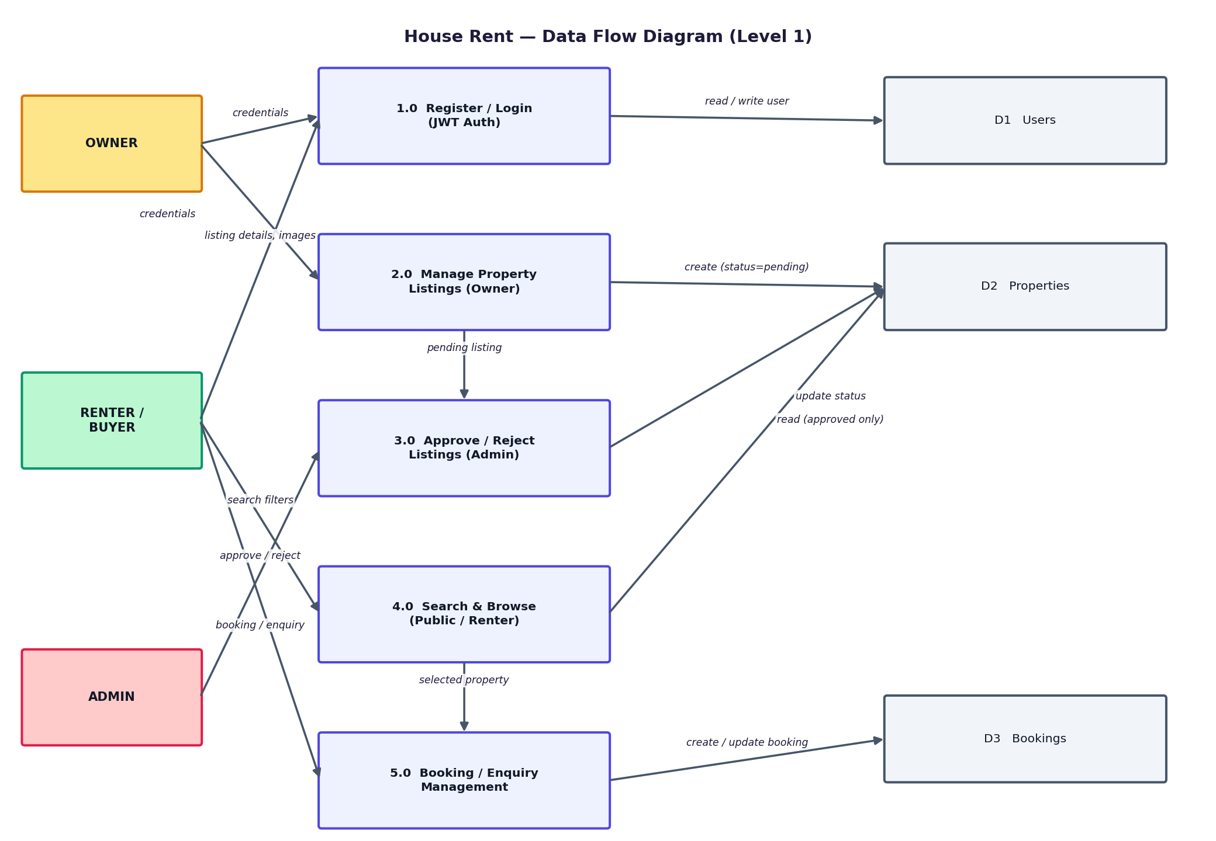
Figure 2: House Rent — DFD Level 1
User Stories
The table below lists the user stories driving each sprint, grouped by user type.
User Type | Functional Requirement (Epic) | User Story Number | User Story / Task | Acceptance criteria | Priority | Release
Renter / Buyer | Registration | USN-1 | As a user, I can register by entering my name, email, password, and choosing Renter or Owner. | I can log in and reach my dashboard | High | Sprint-1
 |  | USN-2 | As a user with an existing account, I can add a second role to it using the same email + correct password. | The account now shows both roles at login | High | Sprint-1
 | Login | USN-3 | As a user, I can log in with email & password and pick a role if my account has more than one. | I land on the correct dashboard for my chosen role | High | Sprint-1
 | Search & Browse | USN-4 | As a Renter/Buyer, I can filter properties by location, price range, property type, and rent/sale. | Results update to match all selected filters | High | Sprint-3
 | Booking / Enquiry | USN-5 | As a Renter/Buyer, I can request a booking or enquiry on an approved, available property. | I see a confirmation and can track status in Booking History | High | Sprint-3
Property Owner | Property Listing | USN-6 | As an Owner, I can submit a new property with images, address, price, and details. | The listing appears in my dashboard marked ‘pending’ | High | Sprint-2
 |  | USN-7 | As an Owner, I can toggle a listing's availability and edit its details. | Editing an approved listing returns it to ‘pending’ for re-review | Medium | Sprint-2
 | Bookings | USN-8 | As an Owner, I can view incoming bookings and mark them booked/sold or pending. | Status change is reflected on the renter's Booking History | Medium | Sprint-3
Administrator | Approval Workflow | USN-9 | As an Admin, I can view all pending properties and approve or reject each one. | Approved properties appear on the public browse page; rejected ones show a reason to the owner | High | Sprint-2
 | User Management | USN-10 | As an Admin, I can grant/ungrant an owner's trusted status and delete accounts. | Grant status is reflected instantly in All Users | Medium | Sprint-4
 | Audit | USN-11 | As an Admin, I can view every property and booking on the platform regardless of status. | Nothing is filtered out of the admin view | Medium | Sprint-4

